**TIM Message Creator**

**Getting Started - Define your Zone**

1. Zoom into the area you wish you begin building.
2. From the top navbar, go to **Show** → **Builder** to bring up the menu to begin building your area.
   * In the **Road Signs** tab, you should see the various road sign options and the **Verified Point Marker**.
3. Click and drag a road sign to the area you wish to begin building. You can only place one road sign per message.
   * Note that the **Markers** Control becomes enabled once the marker is placed.
   * You may drag around the marker after being placed to tweak its location
   * Click on the marker to open up the **Configuration** dialog. From here you can view its Latitude, Longitude, Elevation, and other variables.
   * You may toggle the control back off once you are finished tweaking the location of the markers to lock them in place.

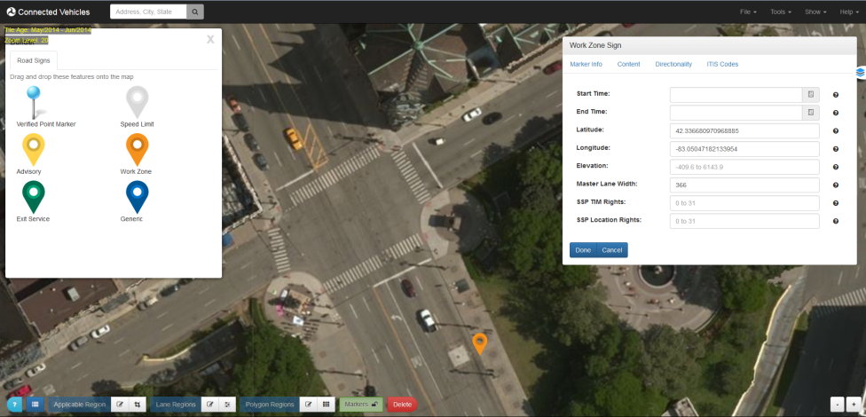

1. Click and drag the **Verified Point Marker** to a known, surveyed location on the map.
   * Click on the marker to open up the **Configuration** dialog. You can view the location of the marker on the map, as well as view and modify the verified location of the marker.
   * Check the verified marker information and edit as necessary. Click **Done** when finished.

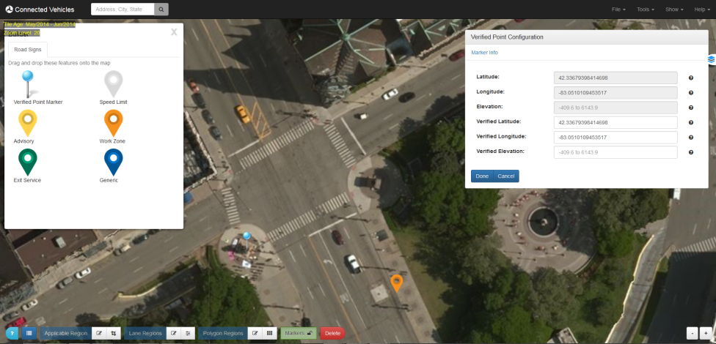

1. Close the **Builder** once you are finished placing the two markers.

#### Defining the Region

1. Toggle ON the **Draw Region** Control from the bottom Control Panel.
2. Drawing a Line
   1. Place the mouse button where you wish to begin defining the region.
   2. Click the mouse once to create the first node of the line.
   3. Click the mouse again to define all subsequent nodes on the line.
   4. Double-click the mouse on the final node you wish to define on the line.

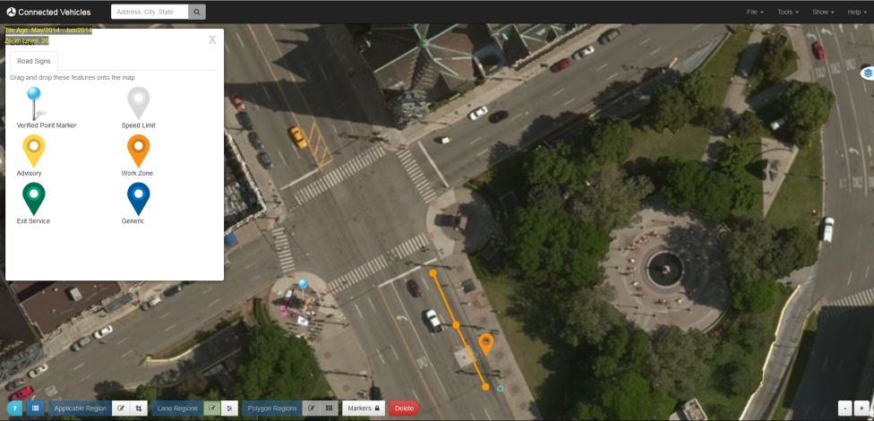

1. Modifying a Line
   1. Toggle ON the **Edit Regions** Control on the bottom Control Panel.
   2. Click the line you wish to modify.
   3. All of the nodes on the line will appear. The solid colored nodes are ones already defined. The transparent nodes are ones you can add to the line by simply dragging them.
   4. Click and drag the nodes around until you have them in the desired position.

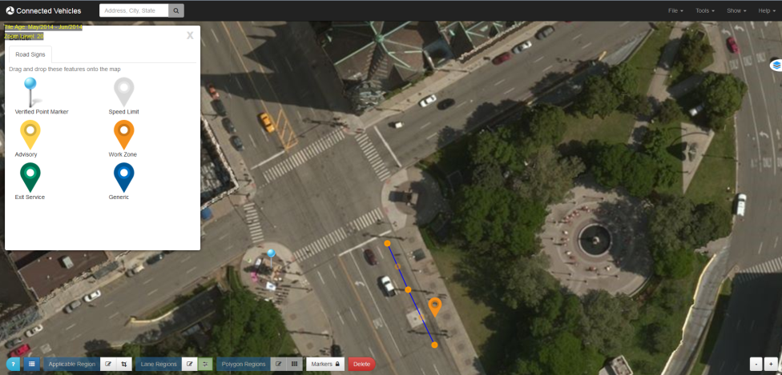

1. Configuring a Line
   1. Verify that all of the Controls on the bottom panel are toggled **OFF**.
   2. Click on the line node you wish to configure in order to being up the **Region Configuration** dialog. Note: only the first node of the line will hold the Lane Number and Attribute information.
   3. Define a Lane Number (node 1). Modify any other desired settings.
   4. Click **Done** when finished.

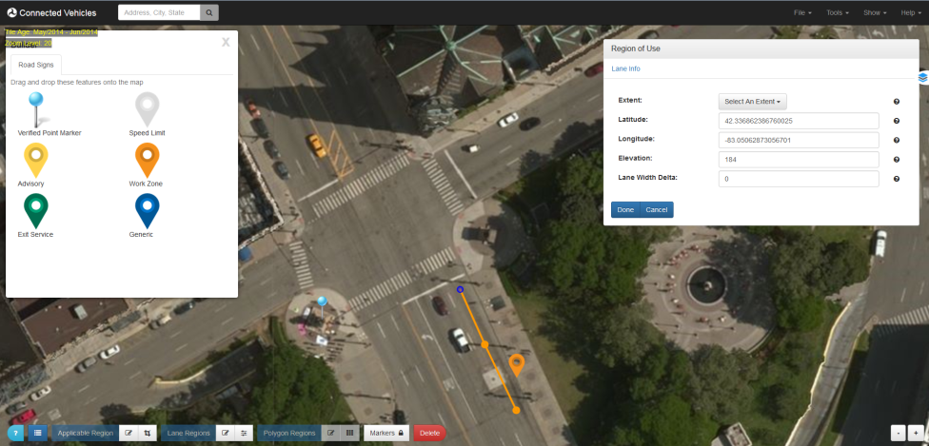

1. Repeat the above steps for each region.
2. Removing a Region
   1. Toggle **ON** the **Delete** Control on the bottom panel.
   2. Click the feature (region) you wish to delete.
   3. Toggle **OFF** the **Delete** Control.

#### Defining the Applicable Region

1. Toggle ON the **Draw Applicable Region** Control from the bottom Control Panel.
2. Drawing the Region
   * Click and drag the mouse to create a rectangular box, symbolizing the area which will allow deposits.
   * Do not worry about the exact size/shape/position of the box as it can be modified.
   * You can only draw one applicable region at a time.

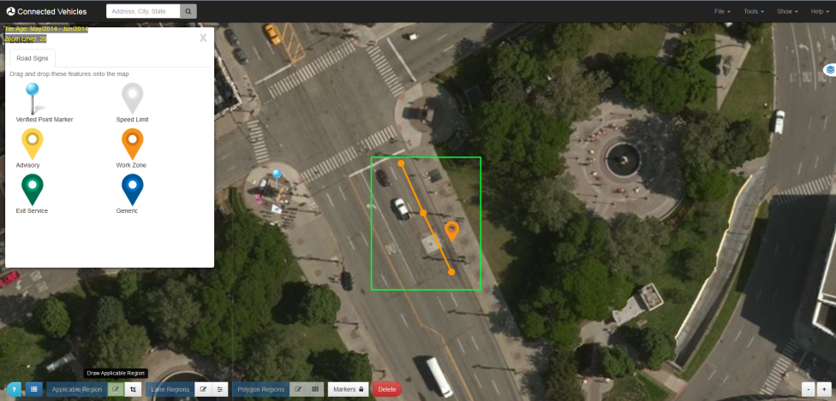

1. Modifying a Region
   * Toggle ON the **Edit Applicable Region** Control on the bottom Control Panel.
   * Click the box you wish to modify.
   * Click and drag from the center dot to move the box around.
   * Click and drag from the outside dot to resize the box.

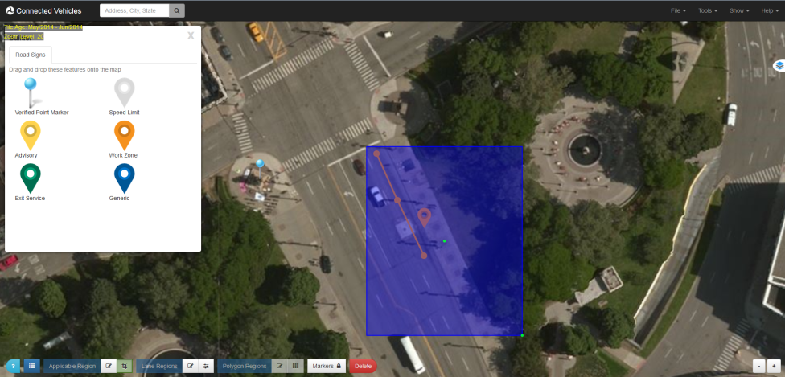

1. Removing a Region
   * Toggle **ON** the **Delete Features** Control on the bottom panel.
   * Click the feature (area) you wish to delete.
   * Toggle **OFF** the **Delete Features** Control.

#### Finish and Encode or Deposit

Encode and/or deposit your TIM message to the warehouse once you are finished building it.

1. Open Encode/Deposit dialog
   1. Click on **Tools** → **Encode/Deposit** to load the deposit window. Unless there are errors, a JSON message should already be generated from the map data. Its contents will appear in the **Message** textarea box.
   2. Verify the contents of the message.

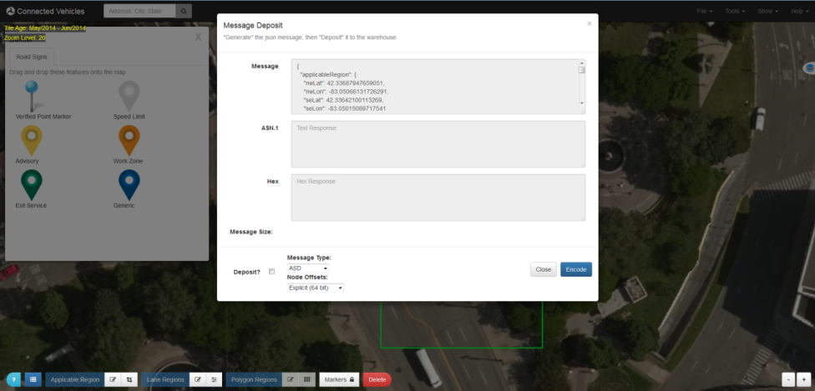

1. Select desired Message Type
   1. **ASD** – ASD Safety Message
   2. **TIM** – SAE J2735 TIM message
   3. **Frame+TIM** – SAE J2735 MessageFrame message with TIM contents
2. Select desired nodes offsets encoding (in the descending order of the message size)
   1. **Explicit (64 bit)** - SAE J2735 Node-LLmD-64b encoding using explicit lat/lon values
   2. **Standard (32 bit)** - SAE J2735 Node-XY-32b offset values
   3. **Compact** – determines and uses the same minimal SAE J2735 Node-XY-??b offset value encoding for all nodes
   4. **Tight** - uses the absolute minimal SAE J2735 Node-XY-??b offset value encoding for each node
3. Encode the Message
   1. Press the **Encode** button to generate the UPER encoding.
   2. The **Hex** text area box will display the hex encoded message if successful, or an error message if unsuccessful.
   3. The **ASN.1** text area box will display the ASN.1 encoded message if successful, or an error message if unsuccessful.
   4. Note that although the cursor in all text areas is the prohibition sign **⃠** because the text areas are read-only, you can select the content of any text area and copy it via standard shortcut keys or a context menu available on the right click. The easiest way to copy all content from a text area is to click in the text area and then type Ctrl-A to select all lines and Ctrl-C to copy to clipboard.

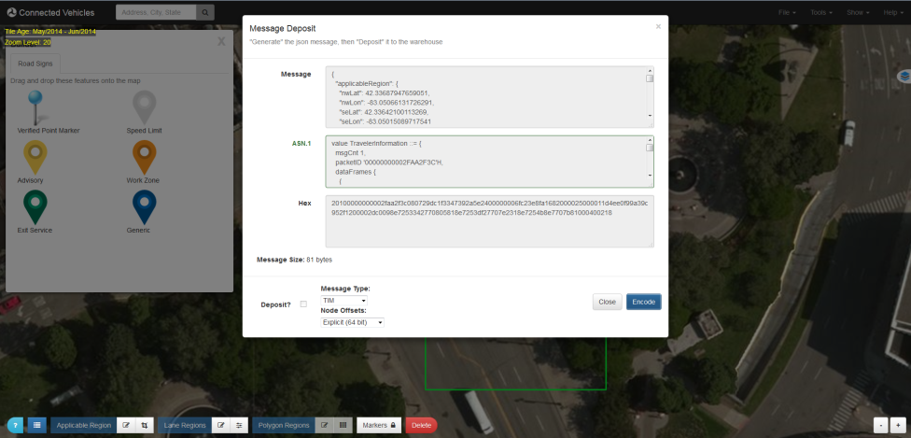

1. Deposit the Message
   1. Click the **Deposit?** checkbox to permit deposit. The button title will change and a **Time To Live** dropdown will appear.
   2. The **Time To Live** variable is optional.
   3. Once complete, press the **Encode/Deposit** button and the encoded messages will appear in the appropriate boxes and the message will be deposited into the SDW.

#### Save and Loading a Zone

Use the save/load feature to save your work locally and pick up where you left off.

* Saving a Zone
  1. From the top navbar, go to **File** **Save**.
  2. Use your browser dialog to save the generated file to your local machine.
* Loading a Zone
  1. Verify you are working with an empty drawing by going to **Tools** **Clear Map**
  2. From the top navbar, go to **File** **Open**.
  3. Use your browser dialog to select the a previously saved zone file from your local machine.
  4. Select and Open the file to begin working on the saved zone.